In the table below these four CNNs are sorted w.r.t their top-5 accuracy on Imagenet data-set. The number of trainable parameters and the Floating Point Operations (FLOP) required for a forward pass can also be seen.

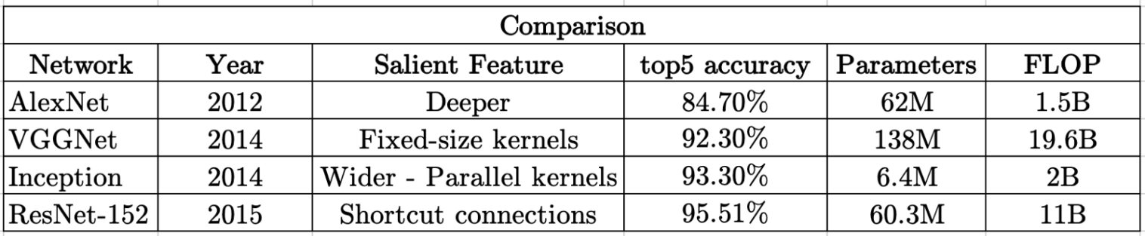

A number of comparisons can be drawn:

* AlexNet and ResNet-152, both have about 60M parameters but there is about 10% difference in their top-5 accuracy. But training a ResNet-152 requires a lot of computations (about 10 times more than that of AlexNet) which means more more training time and energy required.
* VGGNet not only has a higher number of parameters and FLOP as compared to ResNet-152, but also has a decreased accuracy. It takes more time to train a VGGNet with a reduced accuracy.
* Training an AlexNet takes about the same time as training Inception. The memory requirements is 10 times less with an improved accuracy (about 9%)